
A 12
Sreenidhi Institute of Science & Technology
(An Autonomous Institution)
CODE NO: 121ME02
B. TECH. I – YEAR II – SEMESTER EXAMINATIONS, JULY, 2014 (REGULAR)
ENGINEERING DRAWING – II (Common to ECE, CSE & BT)

Time: 3 Hours Max. Marks: 70
Note: No additional answer sheets will be provided.

Part-A
Max.Marks:20

Answer all QUESTIONS.
- An area of 144 sq.cm on a map represents an area of 64 sq.km on the field. Find R.F of the scale for the map.
- What are the applications of development of surfaces?
- Draw the isometric view of pentagonal pyramid with its axis vertical. Side of the pentagon=25mm and axis of the pyramid=60mm.
- Differentiate between the oblique projection and isometric projection.
- Define angle of vision and auxiliary ground plane.
- Write any four editing commands used in CAD.
- Write any three differences between first angle projection and third angle projection.
- How do you classify scales in engineering? Name them with their application.
- What are the different coordinate methods used in CAD to locate a point?
- What are the methods of drawing perspective view?
Part – B
Max. Marks: 50

ANSWER ANY FIVE QUESTIONS. EACH QUESTION CARRIES 10 MARKS.

- Construct a diagonal scale of 1:4000 to show meters and long enough to measure upto 600metres. Show a length of 243 m and 309 m on it.

- Construct a scale of R.F.= 1: 2.5 to show decimeters and centimeters and by a vernier to read mm, to measure upto 4 decimetres.

- A Square pyramid, base 25mm side and axis 65 mm long, is resting on the ground on its base with a side of the base parallel to VP. The sectional plane is inclined at 60⁰, cuts the pyramid at the centre of the axis. Draw the development of lateral surface of the remaining portion of the pyramid.

- A Square prism of side base 40mm and axis 60mm long is lying on the ground plane with a face parallel to and 15mm behind the picture plane. The station point is 50mm in front of the picture plane, 80mm above the ground plane and lies in a central plane which passes through the centre of the block. Draw the perspective view of the block.

- What are the input and output devices used in CAD?

- Draw the isometric view from the given views.

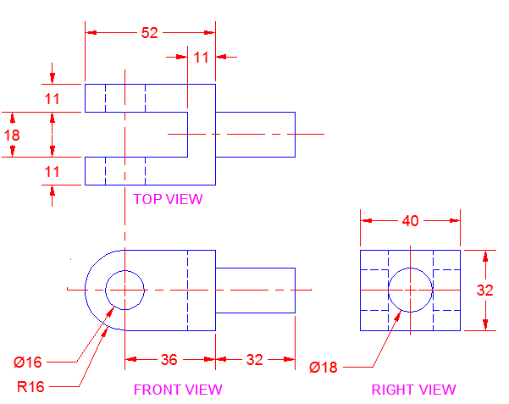

- Draw the isometric projection of a sphere of radius 20mm when it is centrally located on a frustum of a cone. Base and top radii of cone are 35mm and 25mm respectively. Height of the pyramid = 50mm.

- Draw the front view, top view and right side view for the given isometric view.
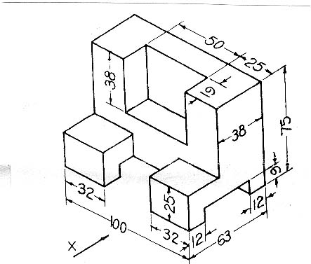

--00 -- 00--

